Name : Tahir Fareed
Roll no : SU92-BSAIM-F24-036
Program : BSAI ( 4-A)

Sentiment Analysis using TextBlob (Python)

1. Introduction
This document explains a Python program that performs sentiment analysis using the TextBlob library. The program takes user input in the form of sentences and determines whether the sentiment is Positive, Negative, or Neutral.

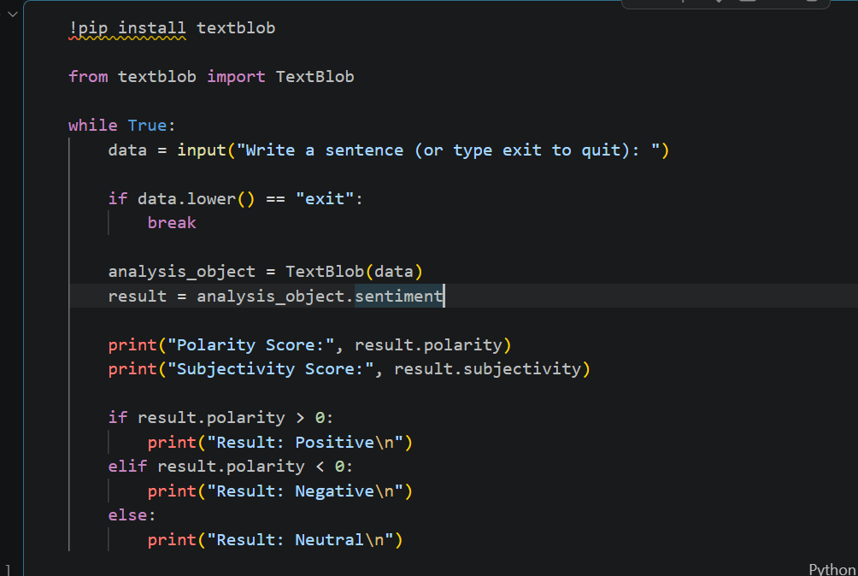

2. Requirements
- Python installed
- TextBlob library installed using: pip install textblob

3. Code Explanation

3.1 Installing and Importing Libraries
!pip install textblob
from textblob import TextBlob
This installs and imports the TextBlob library, which is used for processing textual data.

3.2 Infinite Loop for User Input
while True:
data = input("Write a sentence (or type exit to quit): ")
This loop continuously asks the user to enter a sentence until they type 'exit'.

3.3 Exit Condition
if data.lower() == "exit":
break
This checks if the user wants to quit the program.

3.4 Sentiment Analysis
analysis_object = TextBlob(data)
result = analysis_object.sentiment
This creates a TextBlob object and calculates sentiment scores.
Output screenshot:
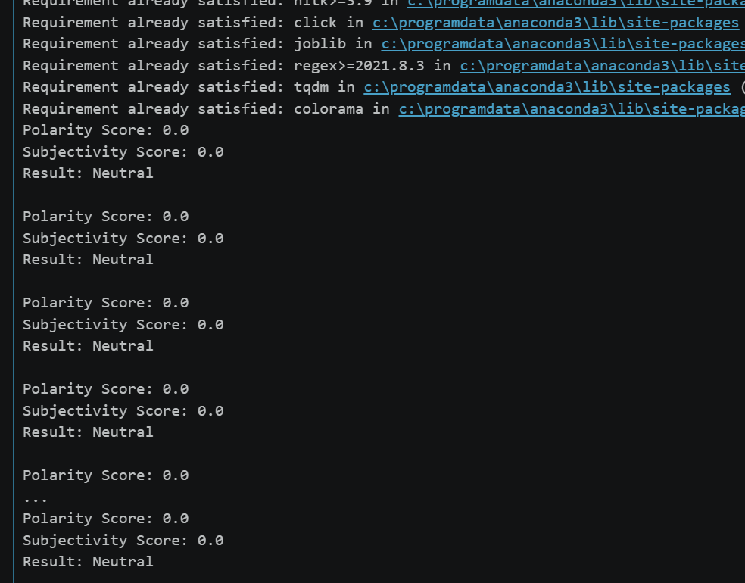

3.5 Output Scores
print("Polarity Score:", result.polarity)
print("Subjectivity Score:", result.subjectivity)
Polarity ranges from -1 (negative) to +1 (positive).
Subjectivity ranges from 0 (objective) to 1 (subjective).

3.6 Classification Logic
if result.polarity > 0:
print("Result: Positive")
elif result.polarity < 0:
print("Result: Negative")
else:
print("Result: Neutral")
This determines the sentiment category based on polarity.

4. Example Output
Input: I love this product!
Polarity Score: 0.5
Subjectivity Score: 0.6
Result: Positive

5. Conclusion
This program is a simple implementation of sentiment analysis using TextBlob. It can be used as a basic NLP project for understanding how text data can be analyzed.

